Pattern Literacy in Support of Systems Literacy

- An approach from a Pattern Language perspective

DRAFT submitted for PLoP17

HELENE FINIDORI University of Hull, Centre for Systems Studies

PETER TUDDENHAM College of Exploration

___________________________________________________________________________________________

To understand and adapt to the world around us, we must get a grasp of how ecological, socio-environmental and socio-technological systems actually work, and how change actually occurs, not only in their ‘mechanical’ aspects, but also in their political, philosophical, psychological, emotional, existential, relational, anthropological, epistemological dimensions. The skills that this requires may be thought of as Systems Literacy. Systems Literacy involves a set of ‘sensing’ and mediating capabilities and tools to (1) make sense of salient patterns and weak signals in growing volumes of information and knowledge, and (2) leverage agency and the complementarity of perspectives, knowledges and know-hows across the board, and help change agents to enter in resonance with each other and their environment. This paper explores the properties of patterns as units of systemic meaning-making and how the development of pattern literacy could support the development of systems literacy. It lays the ground for a pragmatism which enables change agents and systems practitioners to inter­operate from where they are located, with an eye on what is around and the evolving whole. It offers pathways on how the systems communities and the pattern language community could work together to develop such a pragmatism.

Categories and Subject Descriptors: to be completed

General Terms: to be completed

Additional Key Words and Phrases: pattern literacy, semiotics, complex systems, pattern language, complex adaptive modeling, boundary objects, participatory inquiry

**ACM Reference Format:**

Finidori, H. and Tuddenham, P. 2017. Pattern Literacy in Support of Systems Literacy. HILLSIDE Proc. of Conf. on Pattern Lang. of Prog. 24 (October 2017), x pages.

___________________________________________________________________________________________

1. INTRODUCTION

This paper explores the properties of patterns as units of systemic meaning-making and how the development of pattern literacy could support the development of systems literacy.

We believe that understanding our individual and collective approach to pattern recognition, creation, association, and our use of language and other modes of expression is an important step towards systems literacy. In light of the semiotic and pragmatic properties of patterns, we examine here the relations between systems literacy, pattern literacy and pattern languages, and how the three could evolve in interaction.

The paper lays the groundwork for a pragmatism which enables change agents and systems practitioners to inter­operate from where they are located, with an eye on what is around and the evolving whole. It offers pathways on how the systems communities and the pattern language community could work together to develop such a pragmatism[1].

2. THE SYSTEMNESS OF LIFE

Before we encounter the world of different subjects and disciplines our experience of life systems is without boundaries imposed through arbitrary classification and naming.

We begin our lives relating to the world first in terms of biological connections to parents (for most people anyway) and then the ground we crawl on, the food we eat, and the air we breathe. Experiencing place, water, earth and air, family, plants and animals, and life and energy are the worldly experiences we all share from the moment of our birth. These early experiences, fundamental to our existence, form the basis of, and shape our understanding of the world and the patterns we create to navigate life and the nature of our relationships.

As we mature, we learn about life providing and sustaining processes in more formal and fragmented ways. With the complexification of the world, science and practice tend to specialize and function with their own vocabularies and patterns, losing the sense of relationships among things, and therefore the sense of wholeness.

The Meriam-Webster defines a system as *a regularly interacting or interdependent group of items forming a unified whole.* Wholeness and ‘systemness’ are closely related.

Clearly, the issues and challenges the world as a whole is facing are of systemic nature, with systems of different types interacting with each other in more or less predictable ways. They become more unpredictable as complexity grows. To understand and adapt to these challenges we must get a grasp of how systems ‘work’, interact and evolve in interaction with each other and their environments and as a whole. In particular, we must understand how social systems (systems of people) interacting with technological systems affect the environment and how change actually takes place. This involves not only a transdisciplinary approach across hard sciences but also the ‘arts’ and some ‘hidden’ dimensions: political, philosophical, psychological, emotional, existential, relational, anthropological, epistemological, and phenomenological, which all contribute to design or maintain the health and ‘quality’ of socio-environmental and socio-technological systems. The skills needed to cross the various domains of Sciences and Arts and understand the interdependence of things may be thought of as Systems Literacy. Systems literacy may not be sufficient to ensure good governance for a peaceful and sustainable world, but it is definitely a necessary component.

As relatively new disciplines, systems sciences and systems thinking endeavor to take a transdisciplinary approach to systems, the epistemologies and ontologies of which span across various domains of science and practice. In particular they seek to model the interdependencies and understand the flows and dynamics of various types of systems at various levels and scales, providing insights into the interconnected global effects on the planet of the unprecedented human and technology explosion that has occurred and will continue over the coming years.

Systems Sciences and Systems Thinking however have been struggling to disseminate and reach a critical threshold of practice across disciplines and thus still remain confidential. The upside is that these disciplines seek to find general systems laws and concepts that cut across domains, to generalize issues and integrate knowledge. The downside is that they are so abstract that people who are not experts cannot 'relate' to the concepts and language. Added to this is the multiplication of methodologies and approaches to systems, as we will see later in the paper, that make communication and consensus within the systems community difficult.

A Systems Literacy Initiative process was launched as an ongoing international, coordinated effort comprising the ISSS[2], IFSR[3] and INCOSE[4] to create a greater awareness and understanding about "Systems" and to increase systemic capability, and broaden the adoption and practice of systemic approaches.

A direction of this work on systems literacy that we find the most promising and upon which we are building here is to focus on the level of embodied cognition, enhancing human’s innate ‘systemic sensibility’: the non-disciplinary bounded understanding, the sense of wholeness and systemness that people naturally start out with, as we described above. This direction draws on recent similar processes for developing ocean, earth science, and atmosphere literacy[5]. Ocean, earth and atmosphere systems are systems that people can easily relate to because they are part of their worldly experience, and for which natural systems sensibility can more easily be mobilized. The objective as far as systems sciences are concerned is to work at the level of Systemology (the disciplinary field representing the organized body of knowledge about systems) to provide clear concepts and a common language that gives people the “capability to articulate and reflect on this innate sensibility, and act on it in a considered way.”[6]

Without both enhancing systemic sensitivity and generating powerful insights from systems science, we cannot begin to address the interconnected and global effects on the planet of the unprecedented human and technology explosion that has occurred and will continue over the coming years.

We believe however that working directly on systems language and concepts is not enough, and that it is possible to work one level deeper in embodied cognition: on humans’ innate ability to discover, recognize, associate, mobilize patterns, an ability which underpins systemic sensibility. In this respect, we suggest that patterns and pattern language can play a critical role in formalizing the clear concepts and common language sought for in further research in Systemology. Working at the pattern ‘instinct’ and pattern literacy levels can further enhance systemic sensibility and help it transform into systems literacy. We will outline how in the next sections.

3. THE PATTERNNESS OF SYSTEMS

In particular, we believe that working at the pattern level can help overcome differences in epistemological types and languages. These differences arise from the co-individuation[7] processes from which cultures and languages are shaped, resulting in differences in mental models or world views (Maruyama 1980) and in design forms or representations, both at the individual and the collective level.

General Systems Theory was developed around a quest for general systems principles common to all sciences and disciplines, revealed through finding *structural similarities or isomorphisms in different fields* (Bertalanffy 1968). These isomorphisms, also called *isomorphic patterns* in the literature, can be seen as a variety of instances of a general systems principle, or general systems pattern, which applies across sciences. Helping to reveal these underlying similarities in all of life’s experiences by recognizing isomorphic patterns that exist in multiple levels and in multiple domains is a hope for systems literacy.

In a similar approach, the US National Research Council (NRC) and the American Association for the Advancement of Science (AAAS) have developed the Next Generation Science Standards[8]. The NGSS contain Cross Cutting Concepts that apply across Core Ideas of science and in the Practices of science, which can be used as a start point to consider the relationship between science or systems literacy and pattern literacy.

There are seven cross cutting concepts. The first one identified and described as one of the most fundamental cross cutting concept is that of Patterns, that we distinguish here from the other concepts because it is different in nature, with a broader encompassing scope. In Appendix G on the NGSS this first concept is defined as: “Patterns: Observed patterns of forms and events guide organization and classification, and they prompt questions about relationships and the factors that influence them.” The pattern is a unit of observation, a cue, a clue.

The other six cross cutting concepts are: Cause and effect; Scale, proportion, and quantity; Systems and system models; Energy and matter: Flows, cycles, and conservation; Structure and function; and Stability and change. Each of these concepts enable the understanding of specific aspects of systems. All come into play and are interrelated when it comes to describing configuration and behavior of systems.

These six cross cutting concepts could be thought of as pattern categories forming a sense making framework that as a relations system can help find its instantiations in terms of patterns. Patterns here can be defined as the units of systemic meaning-making that repeat and can be recognized and modeled, or designed to influence the course of things. These patterns in themselves, when interconnected, can provide insights and perspective at various levels, from the micro to the meta.

One of the goals of this work on pattern literacy and systems literacy is to enhance our recognition and comprehension of patterns, and further develop—around pattern categories such as the six concepts listed above—sense making frameworks and tools that can help track, use and create patterns to better understand or design systems. One way to achieve this is to describe patterns and represent systems in multiple languages and multiple representations, e.g logograms, kanji, hanzi, 汉字; 漢字 graphical patterns, pictures and diagrams as well as words.

More generally, pattern literacy involves developing a set of ‘sensing’ and mediating capabilities and tools that can help ‘unpack’ and ‘read’ the different dimensions of complexity. This involves (1) making sense of salient patterns and weak signals in growing volumes of information and knowledge, (2) leveraging agency and the complementarity of perspectives, knowledges and know-hows across the board, and (3) helping change agents to enter in resonance with each other and their environment. This is where the theory and practice of Pattern Languages can help.

3. PATTERN LITERACY AND PATTERN LANGUAGE

Christopher Alexander was strongly influenced by systems sciences and systems thinking in the conceptualization of pattern language theory and structure. As a result, there is a strong resonance between pattern language and systemic inquiry and modeling. Systems archetypes are the commonly found patterns or generic structures responsible for recurrent patterns of behaviors in Systems Dynamics.

Inspired by the process of design of vernacular cultures -their ‘timeless way of building’, grounded in tacit knowledge, Christopher Alexander (1979) endeavored, through his work on pattern language, to tap into the layers of our ‘low cognition’ by making the implicit explicit. Alexander’s goal was to produce specific generative, functional or esthetic qualities in the built environment through pattern language. These are systemic qualities.

Alexander’s work and legacy in architecture and patterns of programming however focused mainly on design aspects and less on the semiotic and pragmatic properties of patterns, which are essential elements for learning and embodied tacit knowledge, and key for the acquisition of systems literacy.

Most efforts have been dedicated to discovering, capturing and writing patterns to make them available to practitioners in physical form, but little has been done to ‘embody’ or re-embed this work back into the lower cognition of practitioners and users as opposed to that of experts. In particular the sensing and sense-making aspects of patterns and pattern languages have been neglected, even if these aspects are omnipresent and underpin all of the pattern language work and literature. This is probably why it has been regularly reported that Alexander succeeded from a theoretical perspective, but failed in the application of his theory, as pattern thinking and pattern design failed to become ‘embodied’ into know-how, and their expected results failed to show up in buildings produced.

Pattern language and systems thinking may suffer similar shortcomings: the fact that they are not embedded in tacit knowledge or embodied practice yet and therefore they do not contribute to the establishment of a scalable literacy: designing alive ‘wholes’ and grasping the systemness of things as easily as we speak in natural language. They remain in the realm of expertise or documented knowledge, with either too steep a learning curve, or too prescriptive a knowledge form. According to Dave Snowden (2009), to obtain results in transforming cultures or creating an understanding of existing dynamics, processed micro narratives as reflect of embodied experience are more valuable than documented best practices.

The work of Takashi Iba and his students in this respect is noteworthy. Iba introduced pattern languages of human action (learning, creativity, collaboration, change making etc.), heavily anchored in pragmatism (Iba & Yoshikawa, 2016a), with the recognition of a strong relationship between thought and action, and an objective not only to describe what people should do in a given context, but to change, through practice, people’s habits: these actions that occur ‘un-selfconsciously’ over the long term. Iba also looks at the pattern as a ‘psychic tool’, the sign, mediator between the object and the subject (Iba & Yoshikawa, 2016b). This is not quite far from the pragmatic and semiotic perspective grounded in Peirce’s work (1903) that we are taking ourselves. Iba’s reflective work is put into application and further integrated as learning during pattern dialogue workshops where students reflect over their own learning through discussing patterns. We will further develop this approach in the context of pattern literacy in action later in the paper.

We think there is room in the pattern language practice and for the pattern language community to take a broader perspective on the pattern and expand its definition, and to assist in finding ways to help people ‘grow’ pattern perceiving and sense-making organs, in order to develop a pattern literacy. With the enhancement of pattern literacy, people would be able to ‘speak’ or ‘practice’ pattern language without having to refer systematically to written material. We could think of it as practicing prose: using vocabulary of which we master the definitions, reading or writing the story with a mastery of the grammar rules and syntax without needing to go back to the user manual in order to understand or compose. Isn’t this the essence of literacy? We think that the pattern language community would provide valuable insights to help develop and maintain a language of systems, and find ways to put it to work. In return, the pattern language community would benefit from the expansion of pattern literacy and from introducing some ‘systemness’ in pattern language work.

4. THE PATTERN AS SEMIOTIC SIGN

Patterns are not only recognizable units or instances of scientific observation and understanding within categories of cross-cutting concepts, as described above (in the realm of the ‘objective’). They are also interpretations or mental schemas of these observations (in the realm of the subjective), as well as expressed descriptions or models of these observations (enabling the intersubjective).

We can envision the concept of pattern as a semiotic sign (Peirce, 1903) with three facets (often confused with one another) that all come into play when we seek to understand a system or the world around us. These three facets are (1) the signs and cues that we notice in the environment (the ‘Object’ or system under observation in Peircean semiotic terms[9]), (2) the inferences and mental models through which we make sense of and retain these cues which trigger and shape our decisions and actions (the ‘Interpretant’ in Peircean terms), and (3) the representations we create to describe and communicate about them (the ‘Representamen’ or ‘sign-vehicle’ in Peircean terms). This triadic definition of the pattern as semiotic sign corresponds to Kohls’ three ‘views of patterns’: *patterns in the world*, *patterns in our heads* and *pattern descriptions*[10], and offers a coherent way to interconnect different kinds or instances of patterns.

At the individual level*, patterns in our heads*, as models of the *patterns in the world* that are salient enough for us to perceive, and the ways we express our understanding of one or the other in *pattern descriptions* shape each other through an intricate set of cognitive feedback loops (Kohls 2014 see figure below). These feedback loops are essential in the process of individual understanding and learning, and in the acquisition of any form of literacy.

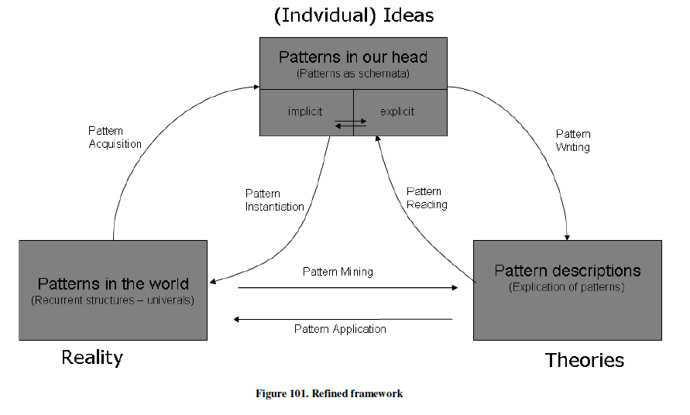

Seen at the group or social level, a same pattern or phenomenological object observed (pattern in the world) may generate multiple interpretations (patterns in our minds) and representations (pattern descriptions). Each interpretation by an observer may be represented using a variety of media, and each representation may in turn generate a variety of interpretations. As a simple example: a tree may be represented by a picture, a pictogram, or an oral or written description. An observed tree may be assumed by different observers to be an ash, or an elm, which look alike. Each observer may depict an assumed ash or elm in different ways, which in turn could be interpreted by others as yet another kind of tree.

Interconnecting a diversity in interpretation and representation combined with various degrees of granularity, allows the combinations of a rich variety of networks of signs and meaning of different natures, and the collective navigation of broader areas of systems knowledge and understanding (Brier, 2008; Johansson, 2013). As a more elaborate example: one could imagine to relate patterns of climate change at various levels of interactions with the various worldviews and positions thereof, and the various types of evidence and communication produced. This would provide stakeholders with a broader picture of the challenges at stake and how different groups approach them: helping to ‘unpack’ and discuss different aspects of the complexity of the issue at different levels, highlighting areas of convergence and divergence, and leading the way to mutual recognition, if not mutual understanding.

By helping us interconnect the variety of our perceptions, interpretations and representations, a higher awareness of patterns and a literacy thereof could help us interconnect more facets of our inner and outer worlds (the implicit and the explicit) and of our inter-subjective interactions as diverse agents in the complex systems we seek to understand and shape, raising our consciousness in the process.

5. THE PATTERN AS UNIT OF EMBODIED COGNITION

In addition to its connective and integrative power, the pattern also has a significant cognitive power as a medium for discovery, decoding and encoding, or in other words learning, with a direct and indirect impact on our decisions and actions. This is why pattern literacy is so critical to systems literacy and systemic change and a potential accelerator thereof.

Patterns play a great role in our cognitive processes seen here as embodied action. One of the essential attributes of the human brain is its propensity and ability to recognize patterns to infer meaning, trigger action and learn. The figure below is an illustration by computer scientist John Sowa (2015) of Peirce’s pragmatic cycle. Different types of patterns and different facets of the pattern as semiotic sign are involved at each ‘moment’[11] of the perception-to-action cycle, connected through different types of cognitive meta-processes. These ‘moments’ are context and perspective dependent.

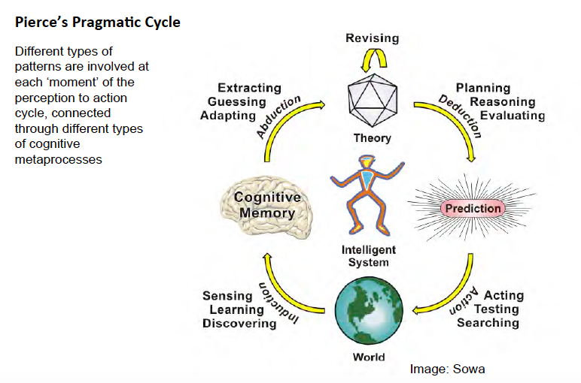

Peirce’s Pragmatic Cycle Illustrated by Sowa

How brains process signal is a key capacity of humans that technology and in particular artificial neural networks have been trying to emulate in machines, with some success as far as big data processing and machine learning are concerned.

For social scientist Howard Margolis (1987), everything in thinking and judgment is reduced to pattern recognition. Margolis describes P-Cognition as a sequence or cycle where a pattern (whether static or dynamic) prompted by cues in a context, becomes itself part of the context, and cues another pattern. Conscious or not, this cycle can happen in multiple cognitive dimensions at once, such as playing the piano while having a conversation. World war two pilot John Boyd (1995) decomposed the fighter pilot intervention cycle into an Observation, Orientation, Decision and Action (OODA) loop where patterns at various levels play a key role. The OODA loop, which Boyd then adapted into a situational awareness model applied to management, unfolds at various paces and with various degrees of reflexivity/consciousness depending on how fast a situation can, needs to, or does trigger a response (immediate sensory/affective or acquired reflex of the fighter pilot, or matured reflection in a strategic planning process).

We do not know how the mind/body works to accomplish this, and in situations of uncertainty we cannot predict or anticipate which patterns we will find and what they will trigger in a given context. A question that often arises is whether human brains are digital or analogue. Quantum physicist and mathematician Freeman Dyson (2014) opts for the analogue (i.e. non-digital, non-algorithmic and therefore non-computable) functioning of the brain, which uses maps to process information and navigates from one map to the other. The structure of thought appears to be associative and essentially a-logical, with chains of thought connecting one memory (or pattern) with another. “*It is by* [*logic*](https://en.wikiquote.org/wiki/Logic) *that we* [*prove*](https://en.wikiquote.org/wiki/Prove)*, but by* [*intuition*](https://en.wikiquote.org/wiki/Intuition) *that we discover*”: Henri Poincaré (1908) studied the role of intuition and analogy in physics and mathematics, exploring his own experience (he was a productive mathematician). For Poincaré, analogical reasoning consists in finding hidden similarities and revealing deep identity of structure among what appears divergent in associations between seemingly disparate concepts or ideas brought about by intuition (Paty, 1994). One can argue that intuition is the manifestation of subconscious analogies or the discovery of new forms, which are then validated or formalized into new patterns in the mind.

The human brain associated with our sensory capacities and motor production capabilities is a pattern-processing and model-making device. The pattern operates at a ‘low cognition’ or un-selfconscious level. In the subconscious, the liminal zone; at the level of embodied cognition, where the tacit, the implicit, the mastery or ‘art’ lie. At a level ‘before’ or deeper than articulated language. The language of thoughts? The language of systems? The language of systems thinking? This is what Christopher Alexander captured so well, and what we would like to re-articulate so that patterns and pattern languages can be operationalized into tools and methods that can better serve systemic inquiry and action[12].

6. IN SEARCH FOR TERRESTRIAL INTELLIGENCE[13]

How then can humans enhance this pattern-processing and model-making capability to understand and integrate multiple contexts, perspectives and levels of analysis and synthesis, and tackle the challenges ahead, which come not only from complex issues but also from the very technological solutions we are putting in place to address them?

In his Medium article *Alien Knowledge: when machines justify knowledge*, David Weinberger[14] highlights the increasing reliance of humans on ‘aliens’, i.e. computers, to develop their own models for understanding the world and the hidden order in systems. These machine learning models bring in so many different variables and contexts that they are often beyond human comprehension. This makes Chris Andersen’s statement on the end of science to the profit of big data a prophecy. “*The new availability of huge amounts of data, along with the statistical tools to crunch these numbers, offers a whole new way of understanding the world. Correlation supersedes causation, and science can advance even without coherent models, unified theories, or really any mechanistic explanation at all*.”(Wired 2008).

Weinberger suggests that computers have surpassed us in the sense that we cannot reproduce the reasoning that led to a delivered result / output. But do we need the reasoning? He asks. Or do we need the ability to see the richness of the ‘true’ world, which is not the ‘reductions’ that our models are presenting us, to grasp both the big picture and the outlier (Snowden), and a sense of direction as to where change is coming from and where it is going? “We thought knowledge was about finding the order hidden in the chaos. We thought it was about simplifying the world. It looks like we were wrong. Knowing the world may require giving up on understanding it.” he writes.

We have entered an era where design surpasses human ability in terms of understanding structures and processes at play as well as outputs produced. As Richard Gabriel envisioned and suggested in a ‘Design beyond human ability” talk, we have designed technology that behaves increasingly like living autopoietic systems, that can not only self-monitor and self-correct or self-repair, but that can also self-design, as they continually (re)create themselves, all the while they continue to produce outputs external to themselves.

The challenge, then, is to keep a capacity to think critically individually and collectively about the validity of the outputs, and the ‘intentions’ or biases or possible unethical criteria that humans may introduce, knowingly or not, in machine algorithms that will iterate into the outputs, only elements visible to us. A pattern language to express algorithm intentions, test the intentions against the code, and the outputs against the intentions could make the validation process easier. This would enable systemic assessment as well

The following question was asked on a systems group on Facebook, which totally encapsulates the questions we as authors are having: "how do you know your algorithms are doing what you intended?" "How do you know the actions you took based on algorithmic insights did not have adverse unintended consequences?" And "Have you ever compared your Big Data insights to those of human sensor networks?"[15]

Human sensor networks enable the harvesting and analysis of community data and micro-narratives in real time. Originally used in natural disaster recovery actions, the practice has been extended to other types of interventions. Dave Snowden (2009) has been deploying technology augmented human sensor networks[16] designed on a science-based approach to the understanding of cognition in the areas of hospital experience and community care, street entrepreneurship in Columbia, and more, which rely on human rather than machine interpretation for detecting patterns, and in particular on communities analyzing and interpreting their own data.

Human systemic skills and insights could be enhanced, and human sensor networks such as developed by Snowden could be enabled at broader scales through the expansion of pattern literacy. Human sensor networks would be a good place to start experimenting with methods and tools for pattern literacy.

A proactive development of pattern literacy can help bridge human and artificial intelligence to better tackle systemic challenges. In hindsight, we are wondering whether that wasn't what Christopher Alexander was after, ahead of his time.

7. PATTERN LITERACY IN ACTION

Because of their ubiquitous and versatile qualities, as connectors of reality, thought and expression (semiotic aspects), and as mediators among different forms of inference and engagement (perception-to-action pragmatic aspects), patterns and pattern languages can be operationalized into tools and methods designed to enhance pattern literacy ‘hands on’. Such tools and methods, oriented towards learning by doing, can be conceived to leverage the cognitive aspects of patterns, those from which an embodied cognitive apprehension of systems becomes possible.

In the following paragraphs, we share a few examples of how patterns and pattern languages, as recognizable connective and mediating objects and systems, can be used to develop sensing/perceiving and sense-making capabilities. We show how experience-based peer learning methodologies (in particular through co-exploring, comparing and confronting perceptions, representations and interpretations), and how adaptive modeling and design skills using simple pattern-based artifacts can help ‘construct’ or ‘deconstruct’ collaboratively encompassing both ‘art’ and ‘science’ perspectives.

7.1 Reading the signs in the environment to find deeper patterns

Tracking patterns on or below the surface (Tristan Gooley, Glanzberg 2017), seeing the obvious or the unseen, reading weak signals (Holland), are key capabilities that helped humans survive or thrive over the ages: the stripes of the tiger, the footprints of the bear, the flight of the eagle or the hawk (Paula Underwood Spencer), the sound of an approaching storm or the anticipation thereof, the alignment of stars in the ocean night, the distress of a loved one or the anger of an enemy… Human’s innate ability to process and mobilize patterns at each moment of the perception-to-action cycle has been lost. Somewhat, our sensing organs have been numbed, and amid the noise generated by information overload and complexity it is urgent that we reclaim them. It is not enough in our current contexts to use our reasoning to model, optimize or maximize in lengthy planning processes. Humans need to re-learn to process signs as they arise, much like the fighter pilot does with the OODA loop, to adapt their actions to uncertain changing complex conditions.

7.2 Acquiring new skills for observing and ‘sensing’, for pattern discovery and sense-making

The (re)learning process includes a (re)discovery of patterns. According to Richard Gabriel and Jenny Quillien, the best design patterns aren't actually ‘designed’, rather they are ‘mined’ in a way similar to scientists mining the universe for mathematically ‘simple’ facts (Gabriel 2017[17]), and then polished into a ‘stable’ design form. Patterns already exist out there, ready to be discovered. Jenny Quillien (2007) on the tracks of Jane Jacobs offers a method to ‘Unravel Problems of Organized Complexity’ by untangling the variables and the smaller segments that compose them:

a) First ‘preparing for analysis,’ where the concern is still with “collection, description, classification, and observations of apparently correlated effects.”

b) Identifying a specific variable just as the biologist singles out, say, an enzyme, and then follows its relationships with other variables.

c) Making our observations in terms of the behavior and not just the mere presence of other specific (not general) variables.

d) Focusing on specific processes and, like Sherlock Holmes, seeking ‘unaverage’ clues that reveal larger patterns.

e) Realizing that these variables “do not exhibit one problem which if understood explains all. They can be analyzed into many such problems or segments which are also related with one another.” And, “when the segments are separated out the behaviors of a variable when in the presence of other variables can be discerned.”

Taking the process to another level, Takashi Iba (2014) uses pattern languages to mine, analyze and visualize experience, in a feedback loop generative simultaneously of additional pattern languages and pattern literacy. The process is illustrated in the figure below.

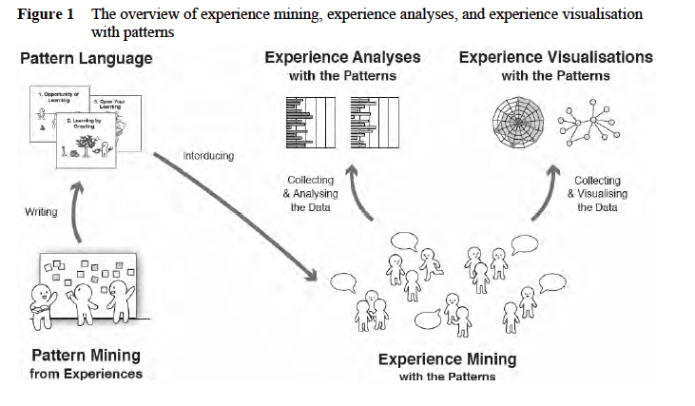

The overview of experience mining, experience analysis and experience visualization with patterns (Iba 2014)

The pattern and experience mining processes at the same time require and help enhance pattern literacy, in a dual learning loop.

7.3 Crossing boundaries

As the popularity and flourishing of domain related pattern languages show, it seems relatively easy or at least feasible to find clues and act in concert across shared, transversal or adjacent domains of experience.

Crossing boundaries in multi-stakeholder, trans-experience domains may be more of a challenge, because what is salient to perceive and retain is not cohesive or of a similar nature or form across contexts.

Iba (ref), working with patterns in the transversal domain of human action, highlights the role of patterns and pattern languages as vocabulary for communication and media to exchange about different kinds of experiences.

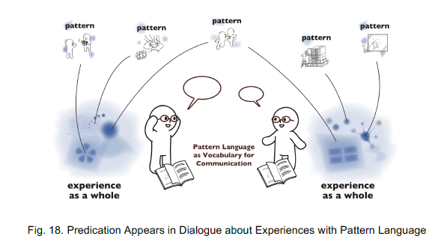

Exchanging about experience through dialogue via patterns and pattern language (Iba)

When we think of systems and what occurs around us, what we perceive, the way we think about what we perceive and the way we describe it are not as objective we may imagine, but rather the result of individual and social processes of communication and co-individuation. These processes which unfold around shared experiences and practices within that which Husserl and Habermas called lifeworlds, shape languages, collective identities and cultures, shared visions and values, but also goals and priorities. Bridging diversity requires tools and methods, as well as mutual learning contexts where possibilities for interoperability of lifeworlds can be found, and where diversity of perspectives and languages can be interfaced at the boundaries of adjacent or disjoined fields of action and knowledge, in view of creating convergence of understanding.

7.4 Patterns as Boundary Objects

With their ubiquitous forms, versatile functions and potential to be represented in a variety of formal structures that can be standardized and digitized, patterns mined from stories or events and expressed as units of micro-narrative, untangled variables or small segments, or systems of interacting forces, can be used as boundary objects.

For Dave Snowden (2009), stories are the fundamental patterning devices through which we communicate, learn, and understand the world in a fragmented unstructured anecdotal way. This patterning occurs using micro-narrative rather than complete stories. These micro-narratives, also known as memes, which arise from and shape our perspectives about things are a natural language expression of patterns of concepts, observation or experience. Stories are fractal in nature, and the capture and exchange of large amounts of micro-narratives determine how our identities are shaped. This is what operates at the family table when we exchange pieces of family stories and consolidate our family identity. When we consciously reflect on these patterns, bringing them from the unself-conscious realm, to the conscious realm, the pattern can serve as boundary object.

Boundary objects are known in sociology as “*objects which are both plastic enough to adapt to local needs and constraints of the several parties employing them, yet robust enough to maintain a common identity across sites. They are weakly structured in common use, and become strongly structured in individual-site use. They may be abstract or concrete. They have different meanings in different social worlds but their structure is common enough to more than one world to make them recognizable, a means of translation. The creation and management of boundary objects is key in developing and maintaining coherence across intersecting social worlds.*” (Star & Griesemer, 1989, p393) There is some clear resonance with the pattern here.

Patterns as boundary objects or units of micro-narrative have a key role to play in collective meaning-making and in mediating communication within and across groups, in ‘plastic’ ways, when it is easier to reflect on smaller elements of a bigger picture, than on a one-piece story or model from which the individual parts are more difficult to apprehend, and which may elicit ‘take-it or leave-it’ types of attitudes. Once patterns are discovered and made explicit, they act as attractors around which opinions can be expressed, clustered and mapped, boundaries probed, controversies identified, and points of view and interpretations confronted and meta-stabilized, using Wikipedia types of processes. What lies ‘in between’ can be explored as boundary objects as well, enabling navigation across complexity factors and dimensions, and ultimately the construction of broader and more structured systemic stories.

In the Plop 2016 workshop documented in the figure below, symbols are being used to compose or decompose ‘systemic stories’, seeking to highlight patterns and show the ‘systemness’ of what is narrated fractally. The patterning process, as learning process, is as important if not more important than the patterns themselves and the final story in the acquisition of pattern literacy.

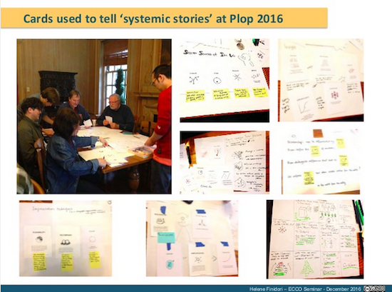

The pattern as unit of micro narrative: cards are used to tell each other systemic stories. Here at Plop 2016

Patterns as boundary objects are effective tools to be used in the course of hermeneutical inquiry (Kinsella 2006) - a co-exploration in meaning and interpretation at various levels of granularity- and in joint discovery journeys, where participants mutually learn from each other, discovering their own blind spots from what others may know, and jointly discovering what is unknown to all (Johari Window, Luft & Ingham 1955).

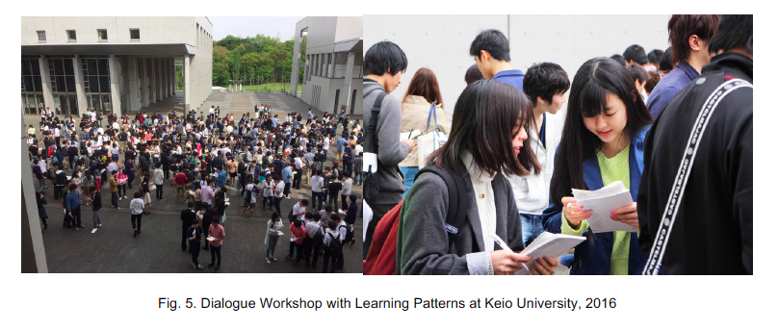

Dialogue Workshop with Learning Patterns at Keio University (Iba 2014)

Iba’s patterns are expressed as small stories, which make them very attractive and easy to take ownership of. The image above shows freshmen students in their first day at Keio University, learning sets of patterns with Iba’s Learning Patterns, exchanging the knowledge they acquired, self-evaluating their knowledge and choosing the areas for further learning. A total of 1000 students (paper refers to 3000 between 2011 and 2014, check with Takashi) are engaged each year in such sessions.

7.5 Adaptive modeling, constructing and deconstructing with our heads and hands.

Because they can be expressed or dealt with, with various types and degrees of formalism, in narrative and natural language, and from the most ‘artistic’ mode (low cognition driven mastery of the art) to the most ‘scientific’ (using reasoning and thorough systematic methods), patterns have the potential not only to become systemic intervention tools, but also systemic research tools, as suggested by Cunningham and Mehaffy[18] (2013).

Initially named diagram in Alexander’s early work (1973), and described as “an abstract pattern of physical relationships, which resolves a small system of interacting and conflicting forces”, the pattern is a subsystem of a ‘near decomposable complex system’ (Simon, 1962) recognizable by the human mind, and recombinable into new models or forms, following grammar-like rules.

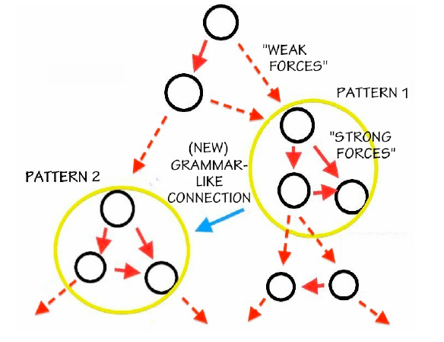

The structural logic of pattern languages. Image from Cunningham and Mehaffy 2013

Unlike one-piece designs, models made of combined patterns created and improved one at a time can be probed and adapted in a purpose-seeking rather than goal-directed manner, thus enabling exploration and learning. Complex adaptive wholes evolve ‘piecemeal’ in the process without predefining specific structures in advance. Fractal stories reinforced through the combination and repetition of micro-narrative follow a similar process.

The ‘grammatisation’[19] of the modeling process provides a method for collaborative sense-making which enables inquiry for each pattern considered, and at each connection (Finidori 2016). This does not necessarily mean that patterns are combined following strict grammatical rules, but rather indicates a breaking down into discrete elements which can be recombined[20]. Grammatization provides possibilities for understanding and a learning and design experience different from those offered by closed one-piece cyclic models such as systems dynamic archetypes. Cyclic processes are often illustrated by feedback loops which are hard to ‘get into’, prompting questions such as where do we start? There are probably no clear or even real beginning, nor end to these pathways. But the first thing observed or the first step taken is always a good step in that it provides a beginning for an inquiry (Finidori 2014b).

In practical terms, purpose-seeking/context-adaptive modeling supported by pattern language as agile technology (Cunningham & Mehaffy, 2013) would consist in decoding (i.e. interpreting and/or articulating) and encoding (modeling and prototyping) problem situations and responses with and into patterns, in order to track changes in configurations, processes and behaviors of pattern encoded objects, and adjust orientation in relation to intent as suggested by Finidori, Borghini & Henfrey in their work on fourth generation pattern languages (Finidori & al. 2015).

This resembles a hacker approach, where objects are deconstructed and reconstructed. The Lego Serious Play method, illustrated below, based on creative imagination and metaphor, where participants ‘learn to think with their hands’, uses 3D Lego forms as shared language for modeling, group discussion, knowledge sharing, problem solving and decision making. How could these types of tools and methods be adapted for pattern literacy and systems understanding?

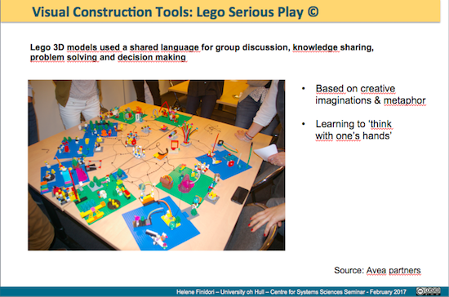

Hands-on construction - Lego Serious Play © - Source Avea Partners.

The process of mining and finding patterns, breaking them down into smaller segments as described above, probing their sustainability and trueness to purpose, assembling them into sequences of aggregate patterns and probing again, and finding ways to express or represent them is part of a peer-to-peer learning process that will enhance systemic awareness and systems literacy.

8. SYSTEMS OF REPRESENTATION: THE QUEST FOR UNIVERSAL PATTERNS

Which types of shared systems of representation, then, are to be used or discovered, when there are multiple learning contexts, and multiple possible languages and forms to describe or approach shared concepts and subsequently multiple understandings and descriptions of the world we live in and of the systems, socio-environmental and socio technological that constitute it?

This multiplicity was illustrated in an exercise proposed during a plenary keynote at the International Society for the Systems Sciences Annual conference in Boulder Colorado in July 2016. Tuddenham handed out 6x4 white cards and asked delegates to: “In addition to using words, I want to encourage the use of symbols as representing principles, big ideas, or concepts in a systems literacy effort. I want you to take this card and “draw a system” and/or draw symbols to represent essential principles or big ideas of systems. And if you would like to, add your name and email to encourage participation.”

Delegates then drew on the cards while they watched two short videos on ocean literacy. At the end of the plenary the cards were collected and photographed. Below is a sample of a few of the 34 cards received. The full set is appended in Appendix I:

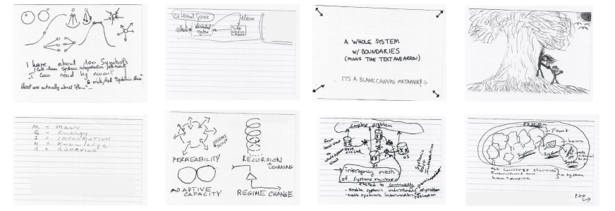

Our harvest (see full set in Appendix I) shows the different points of entry, modes of representation and vocabularies used to represent systems, which Finidori attempted to categorize.

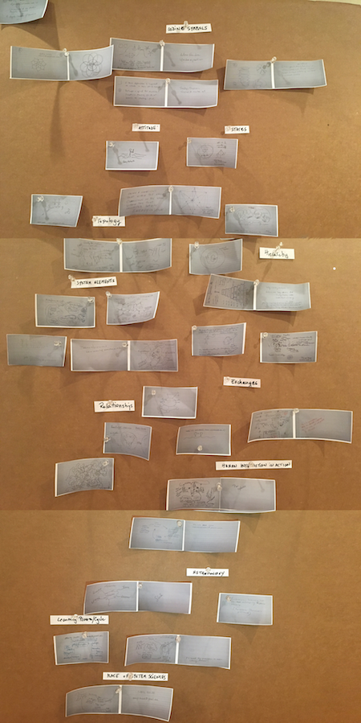 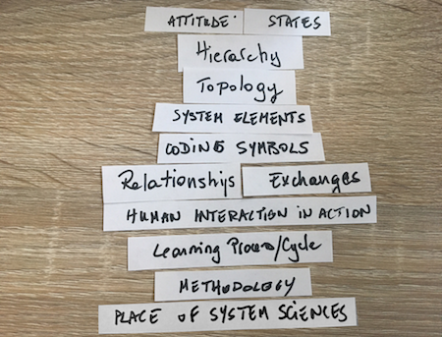

Clustering and labeling by Finidori

We found out that there are multiple ways to cluster and label things, and always some new item that doesn’t fit and needs a new category...

Today there is an increasing demand for transdisciplinarity and integrative systems knowledge. Often however, this materializes by a quest for universals or overarching principles in nature or reality, and for shared visions and representations among observer. Such quest presupposes ‘agreement’ on shared priorities, the prisms through which to see things or the points of entry into an approach, in addition to shared vocabularies and representations. We saw above that vocabularies and representations pertaining to the ‘same reality’ are multiple. Priorities in terms of approaches and action are not ‘interchangeable’ as they are paradigm and preference dependent (Meadows, 1997; Brown, 2005; Finidori, 2013). It took for example ten years to come up with the order and wording of the Earth Charter articles.

The quest for universal principles exists in many domains and disciplines, as attested by Alexander’s life work culminating in the fifteen principles of wholeness and the quest initiated by Bertalanffy for Unity of Sciences through General Systems Principles.

In his *Quest for General Systems Principles*, Rousseau (2017) notes that “although the existence of principles is inferred from the existence of isomorphic systems patterns... knowing more isomorphisms only increases confidence in the existence of principles without making them easier to find.”

In a context where each researcher is developing his own framework, format and methodology, with a diversity of interpretations and representations, as our experiment has shown, and with the multiplication of pattern languages and recorded patterns, is it possible to find universal principles or patterns?

The world wide web is born from a similar quest: finding interoperability between information systems and solving the problem of information diversity and fragmentation, a challenge that single centralized systems and format standards failed to address. Instead Tim Berners Lee made information interoperable through the hyperlink and communication protocols, enabled by html and error tolerant browsers. Now with the semantic web we can go several steps further as we can assign meaning to connections and create clusters of linked data, semantically proximate on any type of criteria we may decide. Semantically inter-connected linked data values difference and keeps data that does not fit anticipated forms. It enables every nuance to be expressed, preserving the richness of the ‘long tail’ and the interconnection of multiple streams of information that reflect the evolution of things and remain alive. This is quite different from stored data that easily becomes ‘dead’.

We subsequently question here whether trying to reach agreement on universal principles, laws or patterns in systems sciences or other sciences, and to capture patterns in databases is not a loss of energy and time. Why not try to connect according to proximity and distance, similarities and differences, and find inter-operabilities between observations, concepts and representations in an ongoing manner?

Gabriel suggests that observing a repeating pattern in the world may lead to some coalescing and generalization, and perhaps extrapolation of what the ‘cause’ of this pattern might be[21].

The interconnection of isomorphic patterns of multiple kinds (in words, image etc.) via semantic relationships into networks or clusters of linked data would create mutual learning environments enabling conversations and the recording of controversies around system issues and general principles. These conversations and controversies, generated around patterns as boundary objects using methods of collective hermeneutical inquiry as described above, would meta-stabilize around strong ‘centres’ such as they exist now in Wikipedia. This would accelerate and bring visibility to a coalescence around ‘similar causes’, making generalizations and extrapolations toward ‘universals’ within reach.

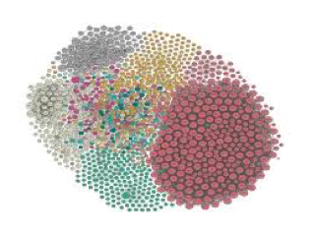

Semantic relationships graph enabled via linked data

Just as words are interconnected in the visual thesaurus[22], where one can physically and visually travel in the word space; one could imagine traveling in clusters of interrelated symbols and non-visual representations of patterns such as those gathered in Appendix II. As an example, the figure below shows Christopher Alexander’s fifteen principles of wholeness illustrated by four different authors including himself. These could be interconnected, and further connected to other patterns and representations to expand the boundaries of Alexander’s work.

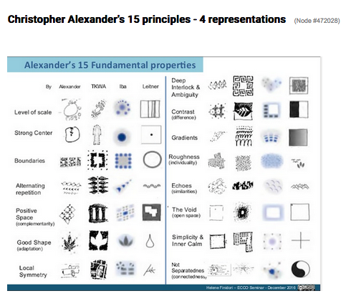

Alexander’s 15 principles - 4 different representations

Nora Bateson’s idea of 'multiple descriptions and interfaces', and search for 'relational data' to show 'multilayered interactions' in complex systems (Bateson 2015) could be powered by a system such as described above, with patterns used as mediators and connectors at the boundaries between and among the different aspects, levels and dimensions of systems and the different perspectives and representations thereof.

The examples above show how we could be working in participatory ways towards comparing interpretations and representations of ‘mined’ patterns, drawing semantic relationships among them, and studying clusters of ‘isomorphic’ patterns to better collaboratively describe common objects of study and discuss or debate among domains. Adopting the approach of the geographer[23] and understanding the different levels from which an observation is made, could help create topographies, networks of ‘patterns that connect’, enabling navigation in the pattern space, and projecting in time (not history projections, but probabilistic – anticipating or possibilizing change).

A key systemic literacy skill would be to be able to recognize one’s space and the existence of other, to navigate within this connected knowledge, and to understand our position in it. This is where pattern literacy becomes essential.

**Conclusion:**

The relation of patterns to embodied cognition and to the understanding of systems is explored here as an introduction to determining the importance of pattern literacy in support of systems literacy. Building upon work on ocean, earth and atmosphere literacy as introduction to systems literacy on the one hand and on work on pattern languages and design on the other hand, this paper describes various properties of patterns. It outlines how patterns can be understood as ‘potentially structured’, scientifically, cognitively and socially recognizable, and interoperable units of systemic meaning-making that can be operationalized into learning tools and methods that can lead to a natural appreciation of patterns in systems, and thus to a better understanding of dynamics of systems and complexity.

The authors think that by taking a broader perspective on patterns and by expanding its definition, in particular as far as the phenomenological and cognitive function of patterns are concerned, the Pattern Language Community could help develop tools and methods to enhance pattern literacy, thus contributing to reinforcing the use and development of pattern languages in general and to enhancing the ‘systemic’ evaluation of patterns in particular. This broader perspective could in addition help the development of a collective intelligence that connects the patterning capability of humans and machines to design and evaluate the sustainability of socio-technological and socio-environmental systems.

We are looking forward to get the communities of Systems Sciences / Systems Thinking and Pattern Language and artificial intelligence to work together on pattern literacy to support systems literacy to this effect. We think moreover that the pattern language community would provide valuable insights to help develop and maintain a pattern language of systems, and find ways to put it to work.

This work will contribute to creating new ways to communicate what systems literacy means. It is a work in progress, establishing steps toward pragmatic application to the complex issues we are encountering, enabling people to explore possibilities from the place where they are located, and learn from there.

**Appendix I**

**Exploring ways to represent systems**

At the ISSS Annual Meeting and Conference in Boulder in 2016 during a plenary session on Systems Literacy the presenter, Peter Tuddenham, asked the participants to take a 4x6 card and to either 1. Draw a System and or 2. Draw symbols to represent essential principles or big ideas (of Systems). The 4x6 cards were a blank space upon which different interpretations of the question were made explicit.

A total of 34 Cards were handed in at the end of the plenary. They have been photographed, anonymized and reproduced below.



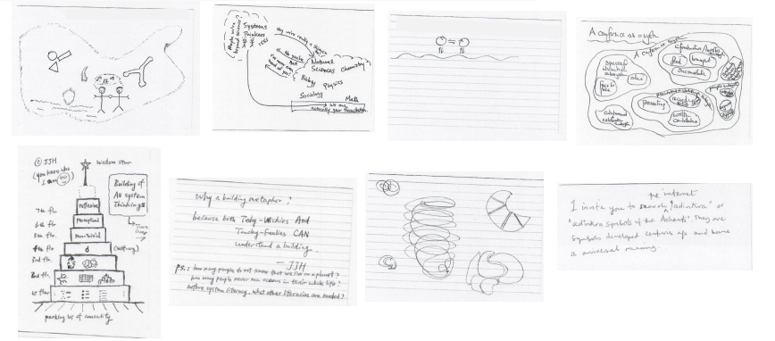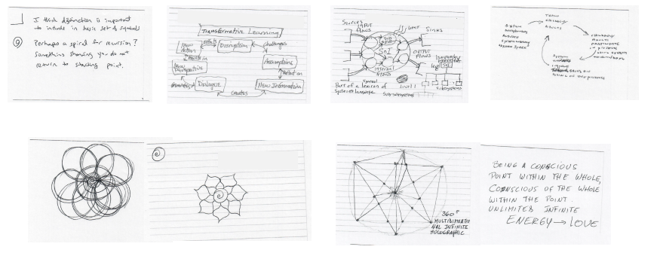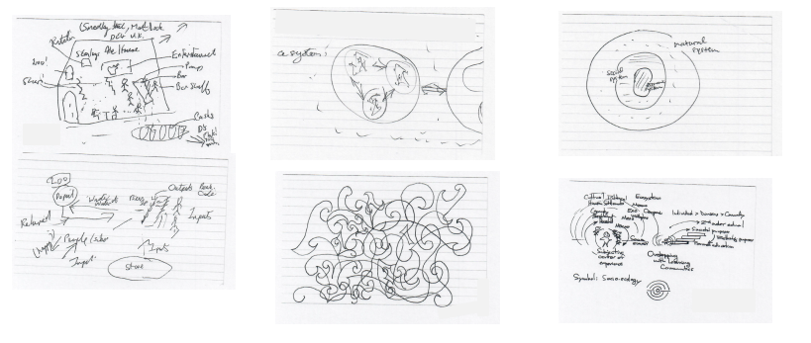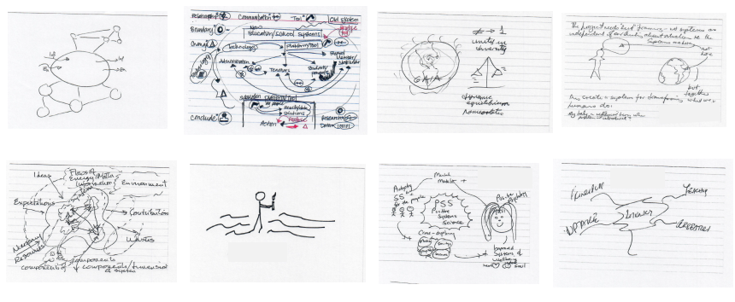

**Appendix II**

**Symbols and non-verbal representation systems**

We gathered here a variety of different types of symbols and non-visual representations that could be used to ‘describe’ or represent systems.

Can we settle on a universal set? How could they be interconnected to find correspondences and enable navigation among different universes of meaning, looking at what clusters appear.



Alexander’s 15 principles - 4 different representations

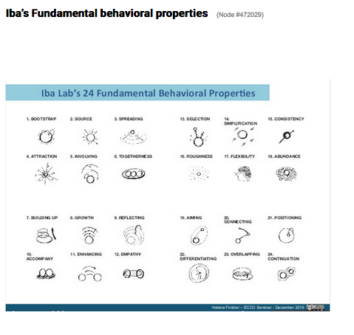

Iba’s Fundamental behavioral properties

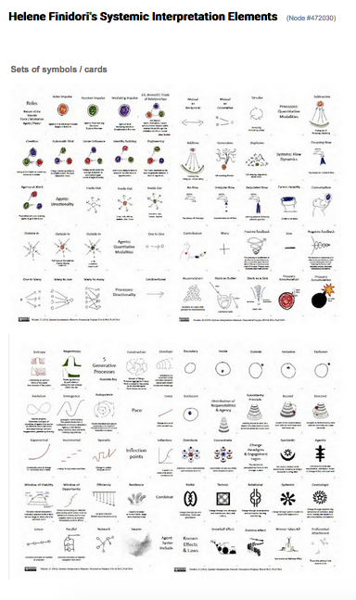

Finidori’s sets of symbols and cards (Purplsoc 2014, Purplsoc 2015, Plop 2016)

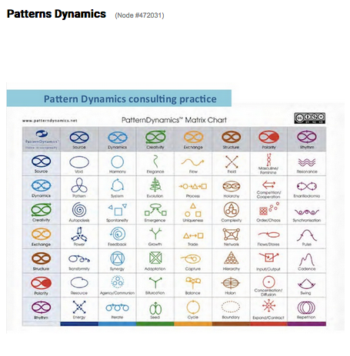

Pattern Dynamics - Consulting Practice (Private conversations 2014 and forward).

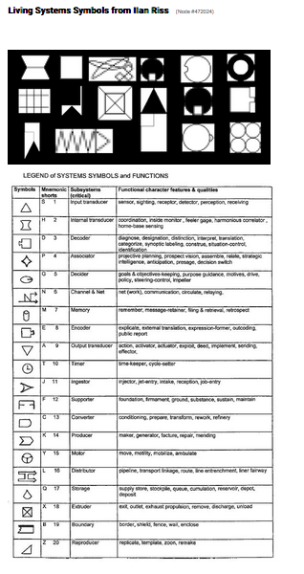 

Living Systems Symbols from Ilan Riss (Presented at ISSS 2016)

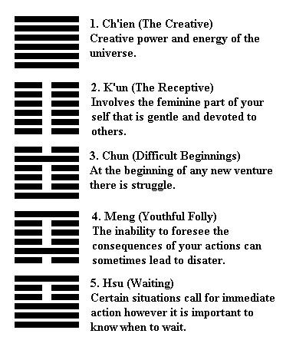

The Tao i-chin

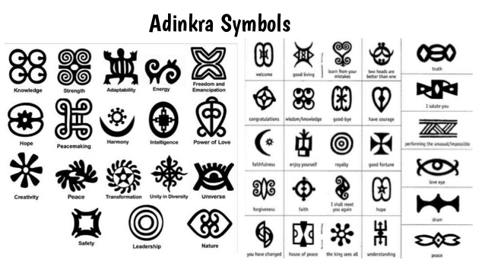

Adinkra concepts: used in African potery and textiles

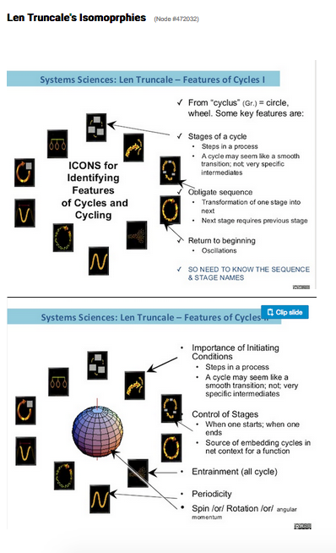



Len Truncale’s Isomorphies: Icons of Cycles (ISSS2016 and previous)

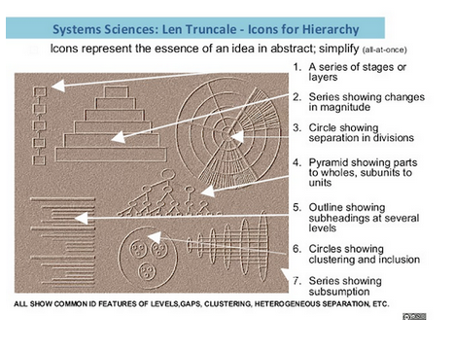

Len Truncale’s Isomorphies: Icons of Hierarchies (ISSS2016 and previous)

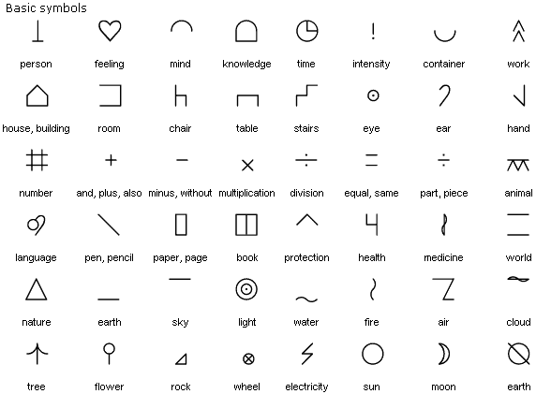

Bliss Symbolic: The written equivalent of the language of signs

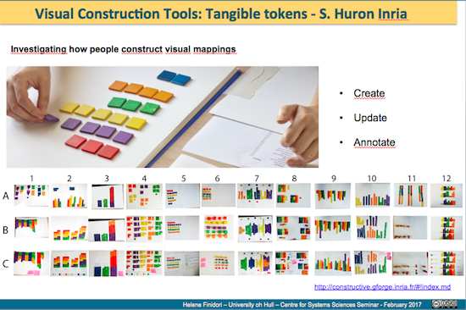

Another type of exercise: Investigating how people create visual representations.

Here: Visual Construction Tools: Tangible Tokens - S. Huron Inria

**Bibliography**

Alexander, C. (1973), *Notes on the synthesis of form*. London: Oxford University Press

Alexander, C. (1979). *The timeless way of building*. New York: Oxford University Press.

Bateson, G. (1979). *Mind and nature: a necessary unity.* New York: E.P. Dutton

Bateson, N. (2015). Symmathesy-A Word in Progress. ISSS Journals. Proceedings of the 59th Meeting.

Bertalanffy, Ludvig von. 1968. *General System Theory.* New York: George Brazilier.

Bowker, G. C., Timmermans, S. Clarke, A.E. & Balka, E. (Eds) (2016). *Boundary objects and beyond: working with Leigh Star.* Cambridge: MIT Press

Boyd, J. R. (1995). *The essence of winning and losing*. [Set of slides]. Available online: <http://www.danford.net/boyd/essence4.htm> [Accessed 6/05/2016]

Brier, S. (2008). *Cybersemiotics: why information is not enough*. Toronto: University of Toronto Press

Brown, B. (2005). Integral Communications for Sustainability, *Kosmos Journal* IV(2): 17­20.

Cabrera, D., Colosi, L., Lobdell, c. 2008. "Systems Thinking." *Evaluation and Program Planning* 299-310.

Cajete, Gregory.,. 2000. *Native Science: Natural Laws of Interdependence.* Santa Fe: Clear Light Publishers.

Capra, Fritjof, and Luisi, Pier Luigi. 2014. *A Systems View of Life: A Unifying Vision.* Cambridge: Cambridge University Press.

Cava, F., Schoedinger, S., Strang, C., Tuddenham.P. 2005. *Science Content and Standards for Ocean Literacy: An Ocean Literacy Update.* Potomac Falls: College of Exploration. http://www.coexploration.org/oceanliteracy/documents/OLit2004_Final_000.pdf.

Cunningham, W. & Mehaffy, M. (2013). Wiki as Pattern Language. *20th Conference on pattern languages of programs.* Monticello October 23rd - 26th, 2013. Available online at <http://bit.ly/1EHSsCN> [accessed 6 May 2016]

Dyson, F. (2014). Are brains analogue or digital? 19th May 2014 - Dublin Institute for Advanced Studies, Statutory Public Lecture of the School of Theoretical Physics, in association with the UCD School of Physics. < http://bit.ly/291hMMu>[retrieved 25 April 2016].

Edson, M.C., Metcalf, G.S., Tuddenham, P., Chroust, G. (Eds.). 2017. "Systems Literacy: Proceedings of the 18th IFSR Conversation 2016." *Systems Literacy.* Sankt Magdalena, Linz,: Johannes Kepler University.

Esbjorn-Hargens, S., Zimmerman, M.E. 2009. *Integral Ecology: Uniting Multiple Perspectives on the Natural World.* Boston: Integral Books.

Finidori, H. (2013). Federating efforts towards a thriving world – How to make it happen? Imagine the common good conference, Paris - August 2013 <http://slidesha.re/1keX4Jy> [retrieved 25 April 2014].

Finidori, H. (2014a). An Ecology for Transformative action & Systemic Change, <http://slidesha.re/1necT88> [retrieved 15 November 2014].

Finidori, H. (2014b). A Pattern LAnguage for Systemic Transformation (PLAST) - (re)Generative of Commons < http://bit.ly/11xD2oF> [retrieved 15 November 2014].

Finidori, H. 2016. Patterns That Connect: Exploring The Potential Of Patterns And Pattern Languages In Systemic Interventions Towards Realizing Sustainable Futures. presented at the 60th Annual Meeting of the International Society for the Systems Sciences - "Realizing Sustainable Futures" - University of Colorado – 23 - 30 July 2016. Soon to be published in the ISSS Journal – 60th meeting.

Finidori, H., Borghini, S. & Henfrey, T. (2015). Towards a Fourth Generation Pattern Language: Patterns as Epistemic Threads for Systemic Orientation. Upcoming Proceedings of the *Purplsoc Conference* 2015 Danube University. Krems, July 2015. Available online at: <http://bit.ly/1TvHEj5> [Accessed 6 May 2016]

Francois, Charles. 1997. *International Encyclopedia of Systems and Cybernetics.* München: KG Saur.

Glanzberg, J. (2017). "A Pattern Mind." <http://patternmind.org/pattern-mind/> [Accessed 20 May 2017].

Hammond, Debora. 2003. *The Science of Synthesis.* Boulder: University Press of Colorado.

Hofstadter, D.R. & Sander, E. (2013). *Surfaces and Essences: Analogy as the Fuel and Fire of Thinking.* New-York: Basic Books

Iba, T. and Yoshikawa, A. (2016b). Understanding Functions of Pattern Language with Vygotsky’s Psychology: Signs, the Zone of Proximal Development, and Predicate in Inner Speech. Proceedings of the 2016 Conference on Pattern Languages of Programs (October 2016), 14 pages.

Iba, T., & Yoshikawa, A. (2016a). Constructing the Philosophy of Pattern Language: From the Perspective of Pragmatism. Paper presented at the PUARL 2016.

Iba, T., 2014. Using pattern languages as media for mining, analysing, and visualising experiences, *Int. J. Organisational Design and Engineering*, Vol. 3, Nos. 3/4, 2014;

Johansson, K.E.L. (2013). Subject and Aesthetic Interface – an inquiry into transformed subjectivities. Doctoral Thesis.

Quillien, J. (2007). "Grasping the Ineffable: From Patterns to Sequences." Environmental & Architectural Phenomenology **18**(1): 4-10.

Kinsella, E.A. (2006). Hermeneutics and critical hermeneutics: exploring possibilities within the art of interpretation. *Forum: Qualitative Social Research* V 7 (3) Available online: <http://bit.ly/1UETY5w> [accessed 6 May 2016]

Kohls, C. (2014). The theories of design patterns and their practical implications exemplified for e-learning patterns. (PhD), Katholischen Universität Eichstätt-Ingolstadt, Eichstätt.

Luft, J.; Ingham, H. (1955). "The Johari window, a graphic model of interpersonal awareness". *Proceedings of the western training laboratory in group development* (Los Angeles: UCLA).

Martin, J., Ferris, T.,. 2008. "On the Various Conceptualizations of Systems and Their Impact on the Practice of Systems Engineering." *INCOSE International Symposium* 577-593.

Maruyama, Magoroh. 1980. "Mindscapes and Science Theories." *Current Anthropology* 589-599.

Meadows, D.H. (1997). *Leverage points: places to intervene in a system*. Hartland: The Sustainability Institute. Available online: <http://bit.ly/1rsFIdv> [retrieved 5 April 2015]

Mobus, G.E., Kalton, M.C. 2015. *Principles of Systems Sciences.* New York: Springer.

National Research Council. Washington D.C. *Convergence: Facilitating Transdisciplinary Integration of Life Sciences, Physical Sciences, Engineering, and Beyond.* 2014: National Academies Press.

National Science Foundation. 2016. *10 Big Ideas for Future NSF Investments.* Accessed May 10, 2017. https://www.nsf.gov/about/congress/reports/nsf_big_ideas.pdf.

Paty, M. (1994). Les analogies mathématiques au sens de Poincaré et leur fonction en physique. *Les analogies mathématiques au sens de Poincaré et leur fonction en physique*, 1994, Paris, France. <<http://bit.ly/293f7nr>>

Peirce, C. S. (1903). Pragmatism as a Principle and Method of Right Thinking. The 1903 Lectures on Pragmatism. P. A. Turrisi. Albany, SUNY Press 1997.

Poincaré, H. (1908) *Science et Méthode*, livre II, ch9

Rousseau, D., Bellingham, J., Wilby, J., & Blachfellner, S.,. 2016. "In Search of General Systems Theory." *Systema* 76-99.

Simon, H.A. 1962. The Architecture of Complexity. Proceedings of the American Philosophical Society 106 (6): 467–482. < http://bit.ly/29aJJqq>[Retrieved 15 May 2016]

Sowa, J.F. (2015). *The cognitive cycle.* Available online: <http://jfsowa.com/pubs/cogcycle.pdf> [Accessed 6 May 2016]

Snowden, D. (2009), Introducing Sense-Maker <<https://www.youtube.com/watch?v=SkRe7Xg7pk4>>[accessed 19 July 2017]

Troncale, Len. 2013. "Systems Processes and Pathologies: Creating An Integrated Framework for Systems Science." *INOCSE International Symposium* 1330-1353.

Underwood Spencer, P. (1990). A Native American Worldview. Noetic Sciences Review (Summer 1990).

Veitas, V. & Weinbaum, D. (2015). Living Cognitive Society: a `digital' World of Views <http://bit.ly/293LrGq> [Retrieved 15 May 2016]

Wysession, M. E., D. A. Budd, K. Campbell, M. Conklin, E. Kappel, J. Karsten, N. LaDue, G. Lewis, L. Patino, R. Raynolds, R. W. Ridky, R. M. Ross, J. Taber, B. Tewksbury, and P. Tuddenham. 2012. "Developing and Applying a Set of Earth Science Literacy Principles." *Journal of Geoscience Education* 60(2), 95-99.

1. This paper continues the work on pattern languages for systemic change presented at Purplsoc 2015: *Towards a Fourth Generation Pattern Language: Patterns as Epistemic Threads for Systemic Orientation (*Finidori & al 2015) and Plop and ISSS 2016: *Patterns that Connect: Exploring the Potential of Patterns and Pattern Languages to Connect Different Forms of Knowledge and Understanding* (Finidori 2016). An encounter at ISSS 2016 with Peter Tuddenham, involved since 2002 in developing a theory and method for Ocean literacy## (reference) and then a project of Systems Literacy initiative (reference), triggered the idea of a joint exploration of the idea of Pattern Literacy in support of Systems Literacy.
2. International Society for Systems Sciences
3. International Federation for Systems Research
4. International Council on Systems Engineering
5. Ref to Peter’s work
6. Quotes from proceedings of IFSR 2016 on Systemic Literacy
7. Co-individuation, a term coined by Bernard Stiegler, is the process of collective individuation (after Gilbert Simondon) through which individual persons become distinct from each other (forming the identity of the I), in relation to each other (forming the identity of the We)
8. See https://www.nextgenscience.org/
9. In Peircean semiotic terms, the pattern is at the same time (1) an *Object* or elementary system under focus (a phenomenological ontological ‘form’, static or dynamic, in its abstractness), (2) the *Interpretant* or understanding, interpretation, or mental ‘decoding’ of the object perceived (the form it takes in the mind), and (3) the *Representamen* or sign-vehicle that represents, signifies or ‘encodes’ this object in relation to its context and interpretation (a physical or explicit formal representation or expression such as a symbol or artifact) through which we communicate). All these forms may reflect observed systemic behavior or structure (observer external to the system in consideration), and they are also subject to triggering behaviors and new structures (observer part of the system in consideration).
10. We acknowledge here and will be reviewing thoroughly Christian Kohl’s thesis and his particular endeavor to link the pattern concept to its original ideas and develop a theoretical framework to understand the relations and differences between patterns in the world, patterns in our heads and pattern descriptions.
11. I am borrowing here the notion of ‘moments’ from Gerald Midgley’s ‘moments of inquiry’ (2000), which I apply in the context of the cognition cycle, a connection Gerald Midgley did not directly make. I will be exploring this notion of moments further in my research.
12. This is the topic of Finidori’s PhD
13. This is also the title of an Essay by Olivier Auber (find link) that Finidori helped translate into English.
14. <https://backchannel.com/our-machines-now-have-knowledge-well-never-understand-857a479dcc0e>
15. Question by Bruce Waltuck, complexity focused organizational change consultant.
16. Watch Dave Snowden on Human Sensor Networks: <https://www.youtube.com/watch?v=ugtCr81C8H4>
17. Private conversation during the shepherding process.
18. As a conclusion to their 2013 Plop paper p.16, Cunningham and Mehaffy suggest that patterns and pattern languages have the quality to become scientific research tools.
19. Grammatisation here is the breaking down of a temporal continuum into discrete spatial elements, reproducible and recombinable. Not the design of syntax and rules for composition. See <http://arsindustrialis.org/grammatisation>
20. The study of the language aspects of pattern language is something the authors would like to explore more in depth.
21. Private conversation July 2017 during the Plop shepherding process.
22. https://www.visualthesaurus.com
23. See the example of Google ‘weaving’ different types of images visualizations in Google maps: https://www.wired.com/2014/12/google-maps-ground-truth/